Need copies or to send a fax?  Did you know that we offer “office” services?  - Black and White Copies - $.25 per page  - Color Copies - $.50 per page  - Scan and Email - $1.00 per page  - Fax - $.50 per page  - Notary - $5.00 per document  - Shredding - $15.00 per bankers box. | About Us  Our Story  Located on the Eastern Plains of Colorado, Agate Networks offers Local and Long Distance Telephone Service and DSL Internet Service to the residents of Agate, Colorado, as well as the homes and businesses located within our 243 square mile territory.  We also offer High-Speed Satellite Internet to the Eastern Plains of Colorado, and parts of Kansas, as well as Internet Security, Identity Protection, and Web and Email hosting services.  We are 100% member-owned and operate under the umbrella of Agate Networks with subsidiary companies of Agate Mutual Telephone Cooperative, Prairie Networks, LLC and Prairie Realty, LLC, a real estate company. Our staff is ready to assist you if you have any questions, or need more information,  Contact Us  Phone: 719-764-2578  Email: amtca@amtca.net  Web: www.agatenetworks.com Facebook: facebook.com/agatenetworks  June 2019 News Letter  38619 Monroe St  Agate, CO 80101 | June 2019
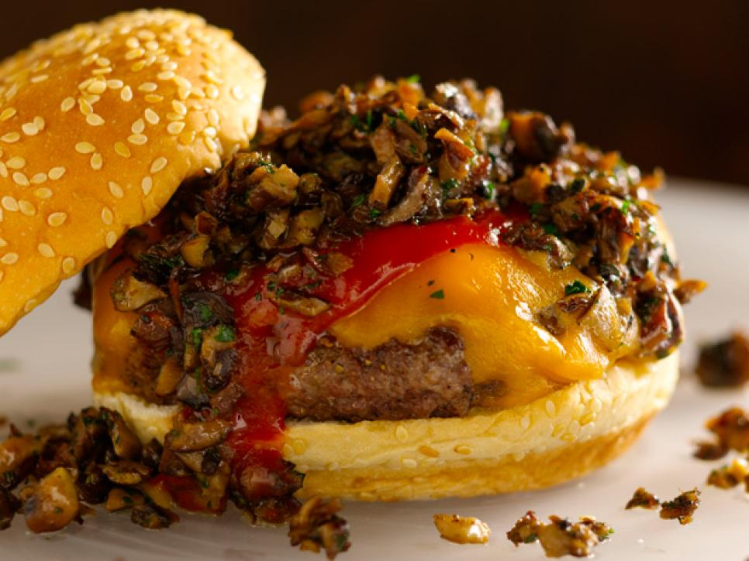  Brought to you by Prairie Realty, LLC- Call us for all your real estate needs! 719-764-3030.  WILD MUSHROOM BURGERS  INGREDIENTS  2 tablespoons olive oil  1 tablespoon unsalted butter  12 ounces assorted mushrooms (such as cremini, lobster, chanterelles, and stemmed shiitakes), chopped  1 small shallot, finely diced  Kosher salt and freshly ground black pepper  1 tablespoon chopped fresh thyme leaves  2 tablespoons chopped fresh flat-leaf parsley leaves  1 1/2 pounds ground chuck (80 percent lean) or ground turkey (90 percent lean)  1 1/2 tablespoons canola oil  4 slices sharp cheddar cheese  4 hamburger buns, split; toasted, if desired (see Cook's Note) | Instructions  - Heat the olive oil and butter in a large saute pan over high heat until almost smoking. Add the mushrooms and cook, stirring occasionally, until soft, about 5 minutes. Add the shallot, season with salt and pepper, and cook until the mushrooms are golden brown, about 5 minutes. Stir in the thyme and parsley and transfer to a bowl.  - Divide the meat into 4 equal portions (about 6 ounces each). Form each portion loosely into a 3/4-inch-thick burger and make a deep depression in the center with your thumb. Season both sides of each burger with salt and pepper.  - Cook the burgers using the canola oil (see Cook's Note) and topping each one with a slice of cheese and a basting cover during the last minute of cooking.  - Place the burgers on the bun bottoms and top each burger with chipotle ketchup, if using, and a large spoonful of the mushrooms. Cover with the bun tops and serve immediately. | Did You Know?  You can sign up for paperless billing and receive your monthly statements via email? Call us at 719-764-2578 to sign up!  You can also pay your bill online with a credit card? Go to www.agatenetworks.com and try it.

